FORMAT FOR PARTICULAR OF STAFF (NRC, NCTE, JAIPUR)
P A R T I C U L A R S O F S T A F F
Name and address of the Institution: Sohan Lal DAV College of Education, Ambala City

S. No. | Name with Date of Birth | Attested photograph of the appointed staff | Whether SC/ST/OBC/other Category | Designation | Qualification | Date of initial appointment and NCTE Regulation under which he or she was appointed | Joining Date | Salary bank account number
I. | DETAILS OF NON-TEACHING STAFF
1. | Mrs. Gurpreet Kaur  12.12.1983 | 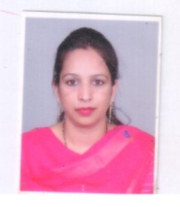 | BC | Clerk | B.A., 3 years diploma in MOP | 07.10.2013 | 07.10.2013 | 3931000100136935
2. | Mrs. Mamta  04.01.1990 | 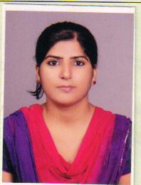 | BC | Steno Typist | M.Com, 3 years diploma in Office Mgt. & Computer Applications | 01.09.2014 | 01.09.2014 | 3931000100149221
3. | Sh. Sanjeev Kumar  10.4.1979 | 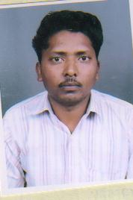 | SC | Library Restorer | M.A. | 05.03.2014 | 05.03.2014 | 3931000100110131
4. | Sh. Deepak Kumar |  | BC | Clerk | B.A., PGDCA | 24.5.2023 | 24.5.2023 | 0521000103042077
5. | Sh. Darbara Singh  10.8.1969 | 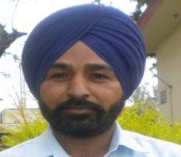 | Gen. | Lab. Attdt. | Matric | 23.8.2017 | 23.8.2017 | 3931000100096433
6. | Sh. Jiya Lal  7.5.1972 | 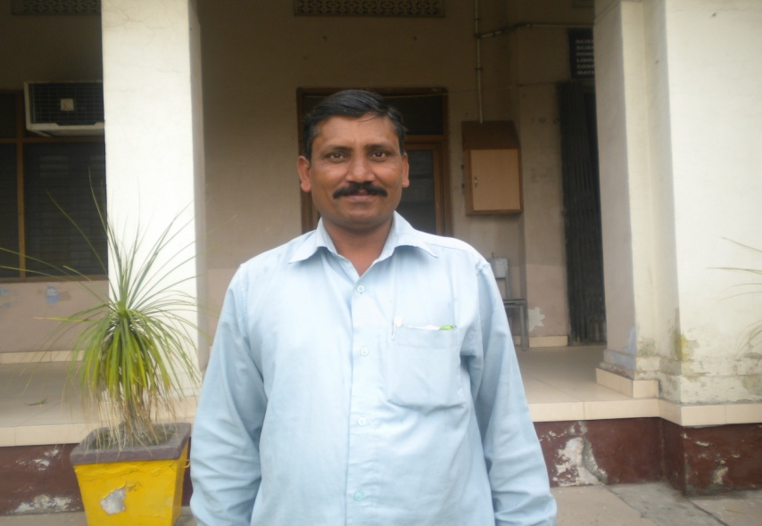 | BC | Chowkidar | Under Matric | 22.5.1990 | 22.5.1990 | 3931000400060046
7. | Smt. Sapna Devi  10.10.1974 | 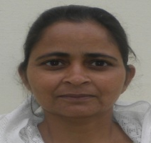 | Gen. | Mali | Under Matric | 15.5.2003 | 15.5.2003 | 3931000100106952
8. | Sh. Rameshwar Parsad Yadav  09.08.1971 | 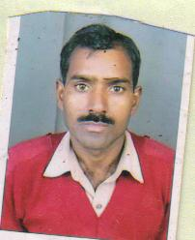 | BC | Peon | Under Matric | 27.10.2014 | 27.10.2014 | 3931000100079010
9. | Sh. Sanjeev Kumar |  | Gen. | Library Attendant | BBA | 12.6.2023 | 12.6.2023 | 3931000100202557

